A:

**Research Survey or No Research Survey ($20,000 cost)**

**Survey**

The question is whether to do the survey or not. Each choice brings its pros and cons. For example, if we choose do the survey it will cost $20,000 and has a 40 percent chance of being negative which will increase the chance of the market being unfavorable to 80 percent. However, on the positive side the survey, if positive, will increase the chance of the market responding favorably to 70 percent. Also, there is a 60 percent chance that the survey will be positive.

If no survey is done there will be no increased chance of a favorable market. However, one has to pose the question would the market be favorable already without the survey? It is true that the market may be favorable already however that is banked on a 50/50 chance and could easily go the opposite direction.

**Yes Survey**

Now that we know a few of the pros and cons, using the decision analysis/decision tree tool in Excel-OM will help us to make sense of all the data and give us a calculated probability that will assist us in making a final decision in store location. The decision tree shows us that if we do the survey and it is positive we have the potential to loose up to $-420,000 and earn up to $680,000 depending on which location we choose. The most likely out come of doing the survey will be earnings of $218,000. This most likely solution occurs if we choose the Stand-Alone Store location. However, if the survey is negative there is also a chance to earn $680,000 or loose $-420,000. However, the most likely amount of earnings in a negative survey is $0 and this is if the Auburn Mall location is chosen.

Yes the survey should be done, by doing the survey we will know two important details: (1) Whether or not build, and; (2) Where to build depending on favorable or unfavorable circumstances. Also, by doing the survey it increases our chances of success and gives the store a greater possibility for a larger return. Doing the survey is a risk. However, the decision tree probability analysis shows that the end payout is likely to be larger in the end. Without the survey we would be shooting in the dark. Through the decision tree analysis we know that if the survey is favorable we should build the “Stand-Alone” store and should expected a profit of $218,000. If the survey is not done the “Stand-Alone” store location is also the option of choice to bring the greatest return on investment. However, everything changes if the survey comes back as unfavorable. The Auburn Mall location would be your number one and only choice to recover the money spent on the survey. Of course, if you knew everything was going to be unfavorable you would choose to not build anything at all. Alas, we do not know but we have percentages of certainty of what is expected to happen and from the probability calculations of these percentages the “Stand-Alone” store location offers the greatest return potential.

As a side note, we would have no need of the survey if the results of option yes survey and option no survey turn out to be the same. Meaning we would we would choose the same location whether or not we would do the survey. For our example, the best location to build if every thing is favorable, survey or not, would be the stand-alone store location. On the other hand, if the survey turned out to be unfavorable we would choose the Auburn Mall store location based on its probability to create a breakeven situation.

**Store Location**

Therefore, if the survey is favorable the “Stand-Alone” store location should be chosen. This option has the highest probability of giving the greatest return. If the survey is not favorable the Auburn Mall location should be chosen.

**2 factors to Consider while Evaluating Location Alternatives for the New Store**

**Assumes the proper percentages have been derived**

(1) The Decision Tree Analysis tool assumes that the proper percentage weights have been derived (i.e. favorable/unfavorable percentages). The whole tool relies on these numbers and if they are wrong then the whole tool is also wrong. Also, these are percentages or expected values not hard facts. Perhaps if the survey is done the chances of favorability may go up to only 55% not to 60%. Would this change where the store location should be built? Perhaps. The point that I am trying to say is, these are probabilities, which are calculated likelihoods. We can never be sure of what will really happen. The decision trees just give our best-calculated guess.

**Which will result in the greatest pay-off**

Of course when we are evaluating location alternatives we want to know which store location is going to give me the greatest return potential. In our case that option is the “Stand-Alone” Store. Though the gross income ranges are calculated in the probabilities it is impotent to note that the gross income ranges are heavier on the positive side. For example, the Stand-Alone store option has a range of gross income from $700,000 to negative $400,000. So besides the fact that there is a 50/50 chance for favorability, 63.64% of the gross income range is weighted towards positive number while 36.36% of the potential gross income range is negative. While assuming the chances of favorable markets it is also important to keep in mind the positive and negative weights. Another, example would be the Auburn Mall store location. Its gross income range is $300,000 to -50,000, which puts 85.71% of the range in the positive income possibilities and 14.29% in the negative. So even if the market is unfavorable there is still only a 14.29% chance that the store will not at least break even.

**Will the market always be Favorable?**

When evaluating locations the company should be looking beyond the here and now but into the future. Building a stand-alone store can be costly and is quite permanent. One would have to ask the question would a mall location come at a lower cost, be more easily shut down and perhaps give some market research in and of it self before building a large permanent stand-alone store? We should be asking questions like: What else will be built around the store in the future? Will it affect our clientele? Is there easy access to the store? Is there enough parking? What is our demographic we are selling to and are they in the potential store location?

**Geological** & **Physical Location**

The actual ground that you put the store on is another thing to consider evaluating a potential store location. Lately there have been reports of sink holes, mud slides, floods, closures do to large amounts of snow, and etc. Near Jerome, Idaho a man built his house on top of a snake den and had to evacuate in the spring when the snakes that were underground moved into the residence. Snakes in a new store could be a catastrophe as well as any other natural disaster possibilities. Geographical location can also effect a possible location based on if the store will have easy access to water, sewage lines, and electricity. When these things are not readily accessible they can be expensive to incorporate into the building plan. City, county or other surveys can be accessed to understand the location of power, water and sewer lines. Then the potential costs can be accurately assessed.

Also, the curb appeal should be considered. A stand-alone location for the store on a busy intersection will surly get more drive by attention than Mall location that is deep inside the Mall. However, a location on the outside of the mall or with an outside entrance would also give the needed drive by traffic and advertising.

**Why I choose the Decision Tool**

The decision tree gives us clear direction by calculating all the probabilities or the most likely event if we proceed in a certain direction. It would take hours of calculations and ultimate care to do the decision tree analysis by hand without mistakes. There are other tools that are available to do a decision tree analysis, like POM and crystal ball however for the minimum amount of branches that needed to be made Excel-OM was a perfect fit to effectively calculate the probability. Other decision analysis tools could run Monte Carlo simulations with thousands or millions of iterations and give is a percent likelihood of the success of each option. But typically such simulations are used with one, two or maybe three variables. Whereas, the decision on where to put the new store has multiple variables. With the increase of variables so does the programing difficultly increase.

B:

**Project Management – Crashing in Excel-OM**

Network Drawing

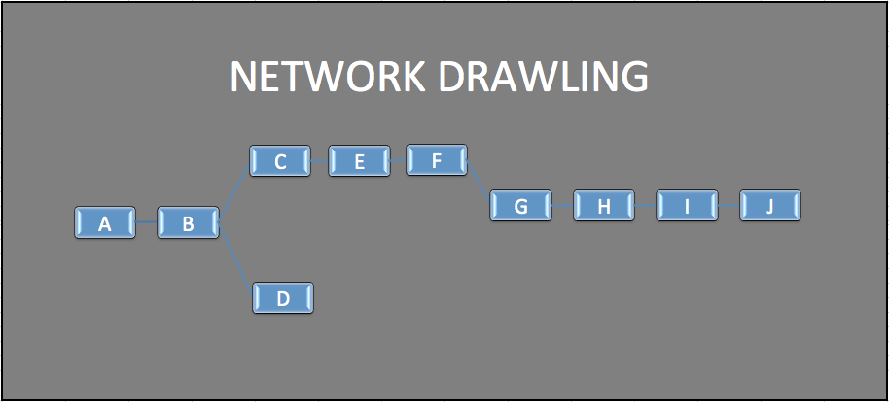

**Identification of the Critical Path for the project**

Is A-J but excludes D because it has slack time. All other activates are critical meaning they have not slack time, which means each activity must be finished before the nest one can start. However, D has a slack time of 19.27 days meaning that C, E, & F can be completed with out being dependent on D to start or finish. But at 19.27 days the task must be completed for G to start.

**How long we should expect the project to take**

108.2 Days

**Number of days to plan on if we want to have a 95% LIKELIHOOD of finishing the project on time frame.**

95% Likelihood to finish on the expected completion time = 122.108499 days or 122 days 2 hours 36 minutes & 14.31 seconds

**If project we crash the project to 5 days earlier than the initial critical path, how would this be accomplished and at what cost?**

Take activity “I” it has a crash time of 5 days and a normal (mean) completion time of 10 days. If the crash time is subtracted from the normal time we get a max time reduction of 5 days. However, to guarantee that the project will get sped up it is going to cost money. In activity “I’s” case, it will cost $500/day. There are three main rules we must abide by when crashing a project (a.k.a speeding a project up). (1) The activity we are crashing must be one the critical path (A-J, “D” is not critical); (2) Must be the least costly activity, and; (3) It must have some possible time reduction available. Therefore we must check the maximum time reduction for the activity. Activity “I” follows all of these rules and as stated before has a max time reduction of 5 days. To decrease the time needed for the activity we need to allocate more resources.

**Project Techniques**

**Use a Gantt Chart for scheduling.**

Gantt Charts are useful when scheduling projects that have a critical path. They show the critical and noncritical activities on a chart like the one above. The “X” axis is the time required and the “Y” axis is the activity. The Gantt chats help to keep a project on time an organized.

**Determine the Critical Path/Network Charts**

A network chart identifies the critical path in a graphical manner showing which activity need to be completed before another one can start. Network charts are extremely useful on big projects where hundreds of thousands of activities need to be completed in an order. Both Gantt and network charts can be used hand in hand to keep a project on schedule and to get the appropriate task done in the right order.

**Crashing a Project**

Crashing a project allows a project manager allocate resources in the most effective and cheapest manner when a project falls behind or needs to be sped up to meet other demands. There are three main rules we must abide by when crashing a project (a.k.a speeding a project up). (1) The activity we are crashing must be one the critical path (A-J, “D” is not critical); (2) Must be the least costly activity, and; (3) It must have some possible time reduction available.

**Calculating project completion times. Z-Score.**

When we want to be a certain percent sure that a project will be completed on time we can use the expected completion time, the project standard deviation and a z-score to add a certain number of days to our expected completion time. In this manner we will know that with the added days we can have certain confidence level that the project will be completed when we said so and not have to pay late fees and extra labor costs.

C:

**Production Plan for Kidshuz shoes & Sneakers.**

The best production plan to minimize costs is to produce 25 batches of Kidshuz and 25 batches of sneakers. With this production plan the required 50 batches will be made.

It would also be a good on idea to allocate production line workers in a 50/50 split; 50% to make Kidshuz and 50% to make the Sneakers. In this way will not have any idle workers and both units, Kidshuz and sneakers, should finish relatively at the same time, depending on production times, delays, etc.

**Optimal Number of Batches of Tassel Loafers and Number of batches of Penny Loafers to maximize total profit and meet the required constraints.**

The best production plan to maximize profit with the Loafers is to produce 120 batches of Tassel loafers and 160 batches of Penny loafers. In this production plan we will maximize our profit while staying within out constraints of total assembly and finishing hours. Also, we will be able to meet out minimum amount requirements for both the Tassels and Penny loafers.

The total number of batches that will be created (Penny Loafers + Tassel Loafers) equals 280 batches. If we calculate the individual batches to the total amount we get approximately 57% to penny loafers and 43% to tassel loafers. We can take these percentages and use them to divide up the production line workers (57% of the production line workers to penny loafers & 43% to the tassel loafers). In this way we can efficiently allocate our production line workers to where the work is and minimize costs of idle workers.

**Decision Analysis Tool Used**

Linear Programing in Excel-OM was used to calculate the optimal number of batches. It was used because both the Loafers and Kidshuz & sneakers problems were maximize and minimize issues with certain constraints. With solver we are able to build a model that helps us to calculate the optimal number of batches that would minimize costs or maximize profits. Solver is able to calculate all the potential possibilities, contingent on the constraints set forth, and we receive the optimal solution. Without solver and a linear programing model finding the optimal solution would be not just difficult and time consuming but also near to impossible. Also, the whole problem was based on a sequential equation with by changing variables (i.e. X, Y – Variables that can change the solution to the problem). By definition this is really what linear program is, it has a start and a finish; Max or Min.

D:

Reordering Practices – Evaluate Variables

Better ways to restock.

When to reorder and how much to reorder can be a difficult decision on the best of days when you know how much demand you will have. However, in the real world, where demand and lead-time, are not known it can really complicate things. A Monte Carlo simulation helps us to be able to you probabilistic calculations from historical data to predict how we can keep up with demand while having a variable lead-time. It would all be much easier if it was star trek and we could just go to our replicator when inventory was down. But until then we will stick to Monte Carlo simulations.

Now James Carter asked me to evaluate an inventory policy of ordering 30 cases of shoes at a time at the end of the business day whenever the ending inventory was 12 cases or lower. This practice sounds good in theory however, I found that unless you already have high starting inventory at the beginning of the 20 days you will encounter lost sales do to stock outages. Also, you must reorder on average 5 to 6 times in 20 days to keep up with demand. There are two things that we are trying to balance when dealing with inventory, holding costs & reordering costs. If we order too much and our inventory sits we accumulate a high holding cost. On the other hand if we have to order six times in 20 days to meet demand our order cost is way to high. We would like to find a balance. A good solution would be to order 60 cases at a time and reorder when inventory hits 15 cases. By doing this we only have to reorder three times in 20 days and we experience no outages because we have a safety stock.

It is important to note that by increasing purchases from 30 to 60 we also double our average inventory on hand. However, since we cut the times we order in 20 days in half and we experience no loss of sales with this method I find the increased holding costs do not outweigh the money saved by ordering more cases per an order.

E:

**Human Resource Strategy to Improve Employee Efficiency & Effectiveness**

When looking at human resource strategy we are looking to achieve two things: (1) Employees are being utilized efficiently “within the constraints of other operations management decisions, and; (2) (Employees) have a reasonable quality of work life in an atmosphere of mutual commitment and trust” (Heizer & Render, 2010). In layman terms, we are trying in to manage labor and design jobs so workforces are effective, safe, consistently paid & treated fairly, and if possible both physically and mentally challenged. After we achieve the above two steps we then need to pull the whole company together to work as a cohesive whole. Easier said than done. However, if you can do it the pay off is huge.

There are three staffing policies to consider: (1) employment stability; (2) work schedules, and; (3) work rules.

**Employment Stability Policy: Flex and Fixed Mix**

Employment stability contains two methods, follow demand exactly or have constant employee number. I would recommend that Shuzworld use a commination of the two methods. Manufacturing plants can have dramatic increases and decreases in demand. Thus, hiring and firing employees as demand dictates sounds like it could be a viable option. However, when there is uncertainty in the duration of employment you must pay a higher price to attract employees. On the other hand keeping a fixed amount of employees can cause employees to be underutilized when demand is low creating idle costs and poor job satisfaction. Having a policy that holds fixed employees at 75 percent of capacity while hiring flexible employees to make up the difference when it is needed can keep costs down and increase employee moral by giving more job security.

**Job Classifications and Work Rules**

Often organizations take on very strict approach as what employees can do and when they can do it. This, type of bureaucracy approach creates inefficiencies by severely decreasing the flexibility that an individual employee has to get work done. For example, often in a unionized organization such as a public university if a clock in a room ceases to function you are not allowed to fix it yourself. Even if you know, the clock just needs new batteries. To fix the clock you must call maintenance and ask them to come and replace the batteries, which usually takes hours if not days. At Shuzworld you want to keep your employees as flexible as possible so the can be utilized in many parts of the manufacturing facility. However, it should be explained that assigned individual areas should be the employee’s first and foremost concern. This is called “Labor Specialization” and was developed by a man named Adam Smith. He believed that by taking multi-skilled artisans and assigning them specific tasks in an assembly process he could reduce the amount of time needed to learn a certain task because of repetition, decrease the amount of lost time from changing tools and jobs in mid process, and decrease the amount of tools each worker needs by assigning only one specific task.

Charles Babbage added one more consideration to job classification. “Babbage suggested paying exactly the wage needed for the particular skill required. If the entire job consists of only one skill, then we would pay for only that skill. Otherwise, we would tend to pay for the highest skill contributed by the employee” (Heizer & Render, 2010). These four considerations should be applied into the manufacturing plant assembly line configurations. I believe that the first three are being followed however; paying employees according to the task versus the skill level of the employee will save the plant money and monetary deficiencies later.

**Job Expansion**

With the above said, increased employee satisfaction is found in variation of the work place. This does not mean that employees need follow a boot or shoe from beginning production to finished product. However, employees can take shifts between different stations. Such cross training of multiple personnel can come in handy when an employee fails to show up at his/her workstation. Remember, the goal is to be flexible and efficient. We can create job expansion in four main ways: (1) Job enrichment, (2) Job rotation, (3) Job enlargement and, (4) Employee empowerment. The figure above is an example that shows how job expansion can be applied within the workplace. It is important to note that an employee that is cross-trained can often result in a higher wage for that employee. This is one of the reasons not all companies implement job expansion into their human resource strategy. Other reasons include: increased equipment or machinery costs, employees that don’t want more responsibility, decreased labor pool because of increased necessity of larger skill base, and higher training costs. However, often companies are compensated with increased productivity, higher quality and decreased employee turnover costs. Strides should be taken to increase employee job satisfaction through job expansion. Take small steps starting with specialization and enlargement.

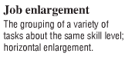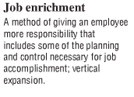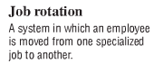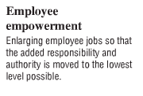

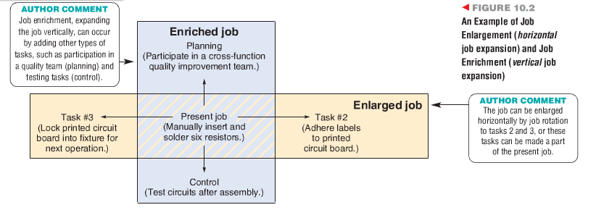

Job Expansion Figure (Heizer & Render, 2010)

**Psychological Components of Job Design**

Jobs at Shuzworld should include these five characteristics: (1) Skill Variety; (2) job identity; (3) Job significance; (4) Autonomy, and; (5) Feedback. Skill variety allows the employee to learn and use many different proficiencies and aptitudes. Job identity lets an employee perceive a start and finish point to a specific job. Job significance allows employees to see how their position effects Shuzworld as a whole. Autonomy means independence or the liberty to use their own discernment in problem solving and day-to-day activities. It allows employees to think and act on their own best judgment. Feedback keeps employee performance in check. Feedback should be clear and done regularly helping employees know their areas of strength and the areas where improvement is necessary.

**Self-Directed Teams**

Self- directed teams are a “group of empowered individuals working together to reach a common goal” (Heizer & Render, 2010). They can be put together for long or short-term purposes. Self-directed teams can give many employees the psychological job aspect that is needed for job satisfaction and can be the source of creative and effective solutions to many company problems. Also, they can be the source of reduced employee turnover because of increased motivation, increased desired responsibility and improved quality and productivity. However, for self-directed teams to be successful mangers need to ensure the necessary training is provided, give needed support and guidance when appropriate, set in place clear goals and objectives, offer incentives that are both financial and non-financial, and supervisors must be able relinquish control and let the team fly.

**Motivation and Incentive Systems**

Of course everyone knows that money motivates many individuals to do a better job. The chance to receive a bonus or a cut of the money saved to increased productivity can really ramp up employees to do better job. However, money incentives are not they only way to motivate. A paid day off, free Shuzworld shoes for the employee and/or family, increased skill or responsibility, etc. can all be systems for motivation. Figuring out what to offer as an incentive is only half the battle. The other half is figuring out at what point do employees receive the incentive package. One way good is to base an incentive system on individual or group productivity. Take the optimal production of Kidshuz and loafers model. If you were trying to complete both tasks by a certain time and date you could create an incentive that rewards the workers if they complete the production and shipment of the products by that date.

Another way to determine when to give incentives could be based on new skills or knowledge. Such skill or knowledge could include new machinery operation, scheduling, budgeting, quality control, certification and/or safety procedures. When an employee learns a new skill or knowledge he or she can receive a pay raise or some other desirable incentive.

**Ergonomics & the Work Environment**

Ergonomics is the study of the relationship between humans and machines and understanding our capabilities and limitations. With the advent of electronics and machines we have to understand what the impact is on our human resources to operate those machines day in and day out. The design of a machine can make a job much easier or it could make it near to impossible. For example, the placement of a computer screen to where the employee sits. The quality of eyesight that an employee possesses can dictate the distance necessary to effectively accomplish a certain task or simply read the screen.

Machinery and tools need to be easy to use and accessible especially in the event that something goes wrong. Training employees on proper use of a certain technology is huge but some times the design of the machine itself makes it impossible to get to individual components or understand what all the lights, signals and switches are saying. Also, to increase employee moral as well as productivity the machines that employees use should be safe. “Illumination, noise and vibration, temperature, humidity, and air quality are work-environment factors under the control of the organization and operations manger. The manager must approach them as controllable” and take strides to ensure they are with in compliance and reasonably comfortable and safe for workers (Heizer & Render, 2010).

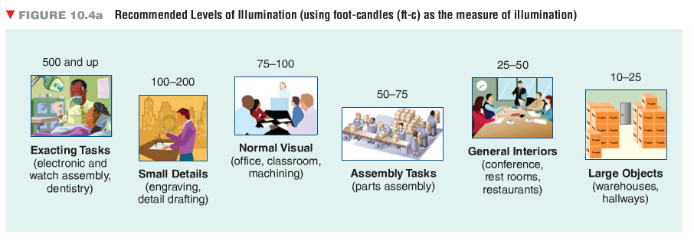The figure above shows the proper amount of illumination for certain types of tasks. 50 to 75 ft-c should be used in the assembly lines at the Shuzworld manufacturing plant.

The figure above shows noise level and at what point a noise is intrusive, ear protection is necessary, annoying and painful. Ear protection should be considered in the Shuzworld manufacturing plant if noise levels exceed an 80.

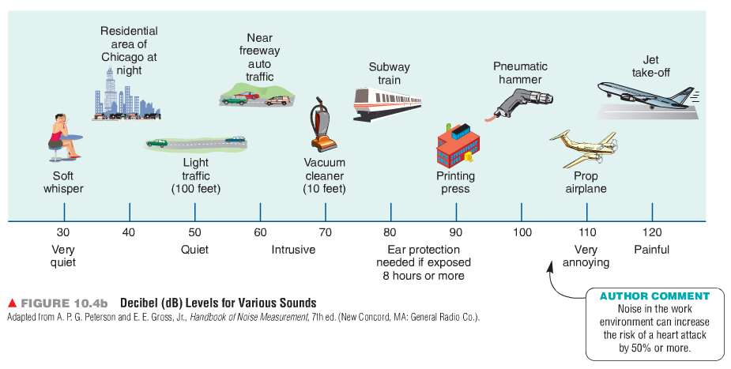

**Methods Analysis**

Some times deciphering where a problem is can be difficult. Often mangers will study how a certain task is accomplished and recommend an improved best method. The best method is the fastest and most efficient way to complete a task. With method analysis you can analyze the movement of individuals or material, body movement or the activity of workers, machines or crews. Flow diagrams can be used at Shuzworld to analyze the movement of individuals and materials to see if they are being used in the most efficient method.

**Labor Standards**

“Labor standards are the amount of time required to perform a job or part of a job. Effective manpower planning is dependent on a knowledge of the labor required” (Heizer & Render, 2010). If labor incentives are going to be applied to the Shuzworld manufacturing plant an excellent understanding labor standards is imperative to its success. Effective operations management requires seven things: (1) Labor cost; (2) Staffing needs: The amount of people needed to meet demand; (3) Cost an Time estimates prior to production; (4) Crew size and work balance (who does what in a group activity or on an assembly line); (5) Expected production (to determine fairs day’s work); (6) What is a reasonable incentive, and; (7) A standard to compare employee efficiency (Heizer & Render, 2010).

You can set labor standards by using historical data, doing times studies, using predetermined time standards or by doing work sampling. Which ever method is chosen labor standards should be figured to meet the necessary demand and avoid large avoidable costs do to insufficient manpower.

**Ethics and the Work Environment**

Ethical behavior is always important when considering a human resource plan. Though perhaps not legally necessary in china equal opportunity and equal pay for equal work should always be applied at the Shuzworld manufacturing plant. Also safe working conditions is crucial to job satisfaction. When considering ethics, laws and environmental controls it is always wise to discuss with local government agencies, insurance companies and the employees.

**Operations Management Philosophies that Focus on Reducing Waste and Increasing Efficiency in Shuzworld’s Production Processes.**

There are two main areas of operations management philosophies that Shuzworld can focus on to reduce waste and increase efficiency, Just-in-Time & Lean operations.

Just in Time, an inventory control theory that allows companies to keep fewer inventories on hand by ordering the stock they need just when they need, as opposed to keeping large amounts of stock on hand. In this model companies like Tortuga are able to eliminate many of the costs of large warehouses, depreciation of goods and wages. As Shuzworld grows its manufacturing plant the ability to make more product than is demanded also grows. Producing to many units over consumer demand is costly and harmful to potential future growth. The following is one way Shuzworld can apply Just in Time Strategies in to its operating procedures:

**“Just in Time” at Shuzworld**

In basic terms Just in Time inventory control at Shuzworld starts where periodic elements are obtained to produce each clothing item and continues to the shelf where the item will be sold. Every Shuzworld supplier must be on board with a Just in Time strategy. It also helps to teach each supplier the importance to running a lean strategy, which is keeping costs low as to offer amazing products at an affordable price.

At first Just in Time may seem complex and daunting. But, Just in Time inventory control at Shuzworld can be as simple as counting how many units are still on the shelves, calculating how fast they are going off the shelf and comparing that to how long it will take you to get a new unit from element to your shelf. For example, lets say you know that it takes 10 days from production to shelf placement to receive new inventory for a Shuzworld line. If you have 110 units left of Shuzworld’s Penny Loafers at your store location and they are leaving at an average rate of 10 units per a day you know an order must be placed no later than tomorrow or the risk of running out and losing sales due to stock outages could very much be real. Below is the scenario in equation form:

Equation Form:

* Units left / Average amount of units leaving per a day = Days left to “out of stock”
* 110 units / 10 units leaving a day = 11 days left until out of stock

Each company varies on when it is decided prudent to order new stock. However, the main fact remains, all companies, including Shuzworld, can save ample amount of overhead costs by applying Just in Time strategies.

A lean operation is similar to Just in Time strategies. However, lean manufacturing takes the idea of ordering a good only when you need it to the next level. Businessdictionary.com describes lean manufacturing as follows: “Doing more with less by employing 'lean thinking.' Lean manufacturing involves never ending efforts to eliminate or reduce 'muda' (Japanese for waste or any activity that consumes resources without adding value) in design, manufacturing, distribution, and customer service processes” (Bussiness Dictionary).

Shuzworld can begin building a lean organization by: implementing JIT (Just in Time) strategies to reduce inventory as discussed above, decreasing traveling distances eliminating many space requirements and waste, and giving responsibility to even the lowest employee which invites the worker to be challenged, have job fulfillment and produce better products. For example, an open management philosophy at Shuzworld can help each employee understand what he/she contributes and costs the company. Such a viewpoint can help the employee know how they can improve and allows them to receive job satisfaction by tangibly seeing how their work has aided in the growth of Shuzworld. Employees that receive more job satisfaction are more likely to go the extra mile and find ways to better their sector: i.e. Customer Service representatives need to have decision making power to solve problems when they arise (within certain guide lines) and not have to wait around for management approval. If employees at Shuzworld are given guidance and responsibility they will arise to the occasion giving them a sense of ownership within Shuzworld and the result will be a more optimistic and successful working environment. Such an environment typically results in better recruits, higher sales and better products. Running a lean operation is Shuzworld’s most important strategy. Running lean depends on three major factors: effective use of budgets, pro-forma statements and decision modeling techniques to appropriately forecast future quarters, and utilize market research.

References

Bussiness Dictionary. (n.d.). *Lean Manufacturing*. Retrieved August 28, 2013, from BusinessDictionary.com: http://www.businessdictionary.com/definition/lean-manufacturing.html

Heizer, J., & Render, B. (2010). *Operations Management 10th edition.* Pearson Addison Wesley.